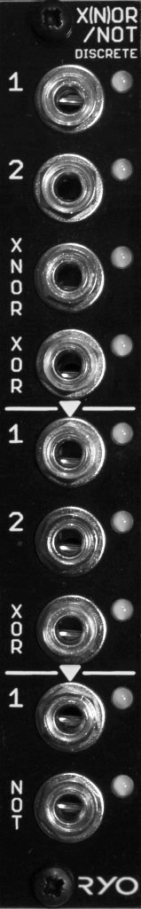


LjunggrenAudio RYO Boolean Logic Series:
Discrete Resistor-Transistor-Logic.

Quickstart – what is the XNOR/XOR/NOT and how do I get going?

The circuitries of the RYO logic gate modules are directly modelled after the very earliest form of digital logic gate designs using resistor-transistor-logic (RTL) pioneered in the 1950s and used in computing equipment throughout the 50s and 60s. The Apollo Guidance Computer for instance used the same type of 3-input NOR gate design now found in the RYO NOR/OR module, although in vastly greater numbers.

Installation

To begin installation, please make sure that:
- you have a standard pinout eurorack bus board
- you have +12V and -12V power rails on that bus board [no +5V supply is required]
- the power rails are not overloaded

!!!Before installing this module disconnect the power from your system!!!

- Double check the polarity of the ribbon cable - The red stripe should be aligned with the -12V rail, on both the module and on the bus board

[we use shrouded headers but it's still possible a cable has been assembled with the stripe on the wrong side of the shroud so always double check!].

Also make sure when using busboards without shrouded headers that the pins aren't transposed a row vertically or horizontally – all pins should insert into holes on the cable.

Although we use both PTC fuses and schottky diodes to provide reverse polarity and excess current protection, we do not take any responsibility for damages caused by wrong power supply connection!

After you have connected everything, double checked it and ensured your case is closed such that no power lines can be touched by your hand or any stray cables drop into holes, turn on your system and test the module

The RTL circuit design gives the modules some interesting quirks thanks to the transistors threshold windows when playing around with different amplitudes, waveforms and frequency rates of the incoming signals, making it fun and useful to explore beyond typical logic gating duties, for example as an audio waveshaper/distortion.

The XNOR/XOR/NOT module is a novice-friendly project, it is a low part count build that only requires basic experience in PCB soldering and module assembly:

The XNOR/XOR/NOT module can be patched as:
- two NOT gates and one 2-input XOR gate,
- one NOT gate, one 2-input XOR gate and one 2-input XNOR/XOR gate,
- two 2-input XNOR/XOR gates, or,
- one NOT gate and one 3-input XNOR/XOR gate.

[insert patch diagrams here]

Gates one and two have two inputs, the third has one. The XOR out from gate one is normalled to input 1 on gate two. The XOR out from gate two is normalled to the single input on gate three (NOT).

The module has signal indicator LEDs on every input and output; Green LEDs light if a signal is present at an input, amber LEDs light when an output goes high.

The module can accept: any input signal between 0V and +5V to +10V peak and outputs logic lows and highs within the Doepfer A100 standard eurorack range of 0V and +5V.

Dimensions
Height: 3U (128.5mm)
Width: 4HP (20mm)
Depth: 50mm (with cable attached)

Weight: ???g

Current consumption
+12V rail 28mA @10V input signals*
-12V rail 0V
+5V rail no +5V supply required

*14mA @5V input signals

Basic specifications
total frequency controllable range DC to 50kHz
max input/output audio signal 20Vpp
CV input range n/a

Max gain n/a

Nominal impedances
Audio signal input: 100k ohm
Audio Signal output: 1k ohm
CV input: n/a

Patch ideas:

below i've included some inspiring words to show patches that can be achieved with the module; and, as ever, experiment – RYO modules are designed with all necessary protection and fail-safes so you can just start plugging in patch cables and see what happens!

it;
many modules

a cv signal;
try something different - such as

Insert patch ideas here;
lorem ipsum got no more patch ideas. lorem ipsum got no more patch ideas. Lorem ipsum got no more patch ideas. lorem ipsum got no more patch ideas. lorem Ipsum got no more patch ideas. lorem ipsum got no more patch ideas. lorem ipsum got no more patch ideas. lorem ipsum got no more patch ideas. lorem ipsum got no more patch ideas. lorem ipsum got no more patch ideas. lorem ipsum got no more patch ideas. lorem ipsum got no more patch ideas. lorem ipsum got no more patch ideas. lorem ipsum got no more patch ideas.

